Belridge Secondary College
Mathematics Specialist Unit 4
Test 4: Calculus solutions

Name: _____________________________

Section One – calculator-free

1. [2, 2, 2, 4 = 10 marks]
Determine the following definite integrals; using the substitution, when given.

- $\int{\frac{6x-9}{x^{2}-3x+2}}$ $dx$ $=3\int{\frac{2x-3}{x^{2}-3x+2}}$ $dx$

$=3ln\left|x^{2}-3x+2\right|+c$

- $\int{\frac{sin⁡(tanx)}{\cos^{2}x}}$ $dx$ using the substitution, $u=\tan{x}$
$=$ $\int{sin⁡(u)}$ $du$ $du=\sec^{2}x dx=$ $\frac{1}{\cos^{2}x}$ $dx$
$=-\cos\left(u\right)+c$
$=-\cos\left(tanx\right)+c$
- $\int{\frac{(1+lnx)^{2}}{2x}}$ d$x$ using the substitution, $u=$ $1+lnx$
$=\int{\frac{u^{2}}{2}}$ d$u$ $du=$ $\frac{1}{x}$ $dx$
$=$ $\frac{u^{3}}{6}$ $+c$
$=$ $\frac{{(1+lnx)}^{3}}{6}$ $+ c$

- $\int{{2cos}^{4}x}$ d$x = \int{{2cos}^{2}x\cos^{2}x}$ d$x$ $cos2x=2\cos^{2}x-1$

$=\int{2}$ $\frac{(cos2x+1)}{2}\frac{(cos2x+1)}{2}$ $dx$ $∴\cos^{2}x=$ $\frac{(cos2x+1)}{2}$

$=$ $\frac{1}{2}$ $\int{{(cos}^{2}2x+2cos2x+1)dx}$ $\cos^{2}2x=$ $\frac{(cos4x+1)}{2}$

$=$ $\frac{1}{2}$ $\int{\frac{(cos4x+1)}{2}+2cos2x+1)dx}$

$=\frac{1}{4}$ $\int{(cos4x+4cos2x+3)dx}$

$=$ $\frac{sin4x}{16}+\frac{sin2x}{2}+\frac{3x}{4}+$ $c$
2. [3, 3 = 6 marks]

- Express $\frac{2x-3}{(x-2)(2x-5)}$ in the form $\frac{A}{x-2}+\frac{B}{2x-5}$

$\frac{2x-3}{(x-2)(2x-5)}$ $=$ $\frac{A}{x-2}+\frac{B}{2x-5}$ $⇒ 2x-3=A\left(2x-5\right)+B(x-2)$

Let $x=2 ⇒$ $1= -A ⇒$ $A=-1$

Let $x=2.5 ⇒$ $2= 0.5B ⇒$ $B=4$

$∴ \frac{2x-3}{(x-2)(2x-5)}$ $=$ $-\frac{1}{x-2}+\frac{4}{2x-5}$

- Hence determine $\int_{4}^{5}{\frac{2x-3}{(x-2)(2x-5)}}$ $dx$ expressing your answer as a single logarithm.

$\int_{4}^{5}{\frac{2x-3}{(x-2)(2x-5)}}$ $dx=$ $\int_{4}^{5}{(-\frac{1}{x-2}+\frac{4}{2x-5}}$) $dx$

$=\left[-ln\left|x-2\right|+2ln\left|2x-5\right|\right]\begin{matrix}x=5 \\ x=4\end{matrix}$

$=\left(-ln3+2ln5\right)-(-ln2+2ln3)$

$=2ln5-3ln3+ln2$

$=ln$ $\left(\frac{50}{27}\right)$

3. [4, 4 = 8 marks]

- Using the substitution $x=cosθ$ show that $\int_{\frac{π}{4}}^{\frac{π}{3}}{\tan^{3}}θdθ=$ $\int_{m}^{n}{\left(\frac{1}{x}-\frac{1}{x^{3}}\right)}dx$ and state the values of $m and n.$

LHS $=$ $\int_{\frac{π}{4}}^{\frac{π}{3}}{\tan^{3}}$ $θdθ=$ $\int_{\frac{π}{4}}^{\frac{π}{3}}{\frac{\sin^{3}θ}{\cos^{3}θ}}$ $dθ$ $x=cosθ ⇒ dx=-sinθdθ$

$=\int_{\frac{π}{4}}^{\frac{π}{3}}{\frac{\sin^{2}θsinθ}{\cos^{3}θ}}$ $dθ$ $θ=$ $\frac{π}{3}$ $⇒ x=$ $\frac{1}{2}$

$=\int_{\frac{π}{4}}^{\frac{π}{3}}{\frac{{(1-cos}^{2}θ)sinθ}{\cos^{3}θ}}$ $dθ$ $θ=$ $\frac{π}{4}$ $⇒ x=$ $\frac{1}{\sqrt{2}}$

$=\int_{\frac{1}{\sqrt{2}}}^{\frac{1}{2}}{\frac{\left(1-x^{2}\right)}{x^{3}}}$ $(-dx)$

$=$ $\int_{\frac{1}{\sqrt{2}}}^{\frac{1}{2}}{\frac{\left(x^{2}-1\right)}{x^{3}}}$ $dx$

$=\int_{\frac{1}{\sqrt{2}}}^{\frac{1}{2}}{\left(\frac{1}{x}-\frac{1}{x^{3}}\right)}$ $dx=$ RHS with $m=$ $\frac{1}{\sqrt{2}}$ and $n=$ $\frac{1}{2}$

- Hence, or otherwise, evaluate $\int_{\frac{π}{4}}^{\frac{π}{3}}{\tan^{3}}θdθ$ exactly.

$\int_{\frac{π}{4}}^{\frac{π}{3}}{\tan^{3}}θdθ =$ $\int_{\frac{1}{\sqrt{2}}}^{\frac{1}{2}}{\left(\frac{1}{x}-\frac{1}{x^{3}}\right)}dx$

$=$ $\left[ln\left|x\right|+\frac{1}{2x^{2}}\right]\begin{matrix}x=\frac{1}{2} \\ x=\frac{1}{\sqrt{2}}\end{matrix}$

$= \left(ln\left(\frac{1}{2}\right)+2\right)-(ln\left(\frac{1}{\sqrt{2}}\right)+1)$

$=-ln2+2+\frac{1}{2}ln2-1$

$=1-\frac{1}{2}ln2$

End of Section One

Section Two – calculator-assumed

4. [3, 5 = 8 marks]

The graph of the curve of equation $\sqrt{x}+2\sqrt{y}=6$ is shown below. The line of equation $x+2y=12$ is tangent to the curve at point P. The shaded region is enclosed by the curve, the tangent line and the $x$ axis.
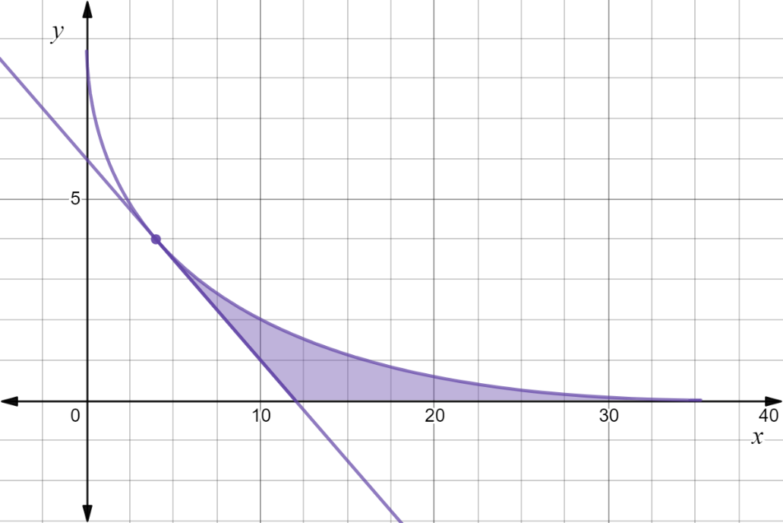

P

- Find the co-ordinates of point P and the $x$ intercepts of the curve and the tangent line.
$P=(4,4)$ and $x$ intercepts at $x=36 and x=12$

- Find an integral expression for the area of this region in terms of
- horizontal elementary slices
$\sqrt{x}+2\sqrt{y}=6 ⇒$ $\sqrt{x}=6-2\sqrt{y } ⇒ x={\left(6-2\sqrt{y }\right)}^{2}$

$x+2y=12 ⇒ x=12-2y$

$∴$ Area$=\int_{0}^{4}{{\left(6-2\sqrt{y}\right)}^{2}}dy-\int_{0}^{4}{\left(12-2y\right)}dy (=16 as a check)$

- vertical elementary slices
$\sqrt{x}+2\sqrt{y}=6 ⇒ \sqrt{y}=$ $\frac{6-\sqrt{x}}{2}$ $⇒ y=$ $\frac{{\left(6-\sqrt{x}\right)}^{2}}{4}$

$x+2y=12 ⇒ y=6-$ $\frac{x}{2}$

$∴$ Area$= \int_{4}^{36}{\frac{{\left(6-\sqrt{x}\right)}^{2}}{4}}$ $dx-$ $\int_{4}^{12}{\left(6- \frac{x}{2} \right)}$ $dx$ $(=16 as a check)$

5. [4, 4 = 8 marks]

For the curves with equations $2y2 -9x=0$ and $y2-12x+60=0$ determine the volume of the solid formed when the region enclosed by the two curves is

- rotated about the $y axis.$

$2y2 -9x=0⇒x=$ $\frac{2y^{2}}{9}$ and $y2-12x+60=0⇒x=$ $\frac{y^{2}+60}{12}$

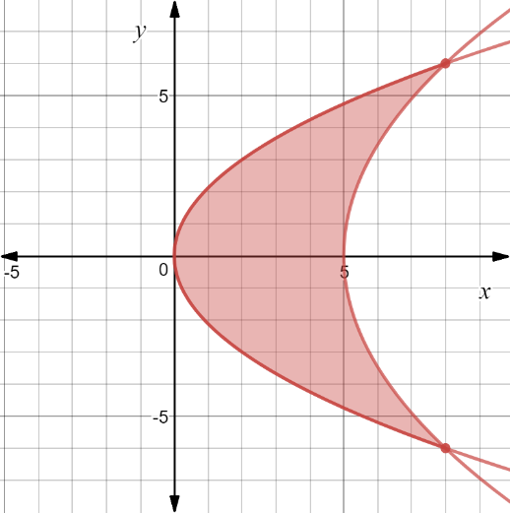
$V_{y}=π\int_{m}^{n}{x^{2}dy}$

$=π$ $\int_{-6}^{6}{{\left( \frac{y^{2}+60}{12}\right)}^{2}}$ $dy-π$ $\int_{-6}^{6}{\frac{4y^{4}}{81}}$ $dy$

$=2π$ $\int_{0}^{6}{{(\left( \frac{y^{2}+60}{12}\right)}^{2}-}$ $\frac{4y^{4}}{81})dy$

$=288π$ ${unit}^{3}$

$≈904.78$ ${unit}^{3}$

- rotated about the $x$ axis

$2y2 -9x=0⇒y^{2}=$ $\frac{9x}{2}$ and $y2-12x+60=0⇒y^{2}=12x-60$

$V_{x}=π\int_{a}^{b}{y^{2}dx}$

$=π$ $\int_{0}^{8}{4.5x}$ $dx-π$ $\int_{5}^{8}{\left(12x-60\right)dx}$

$=90π {units}^{3}$

$≈282.74$ ${units}^{3}$
6. [5 marks]

A bucket has a circular base of radius $r$ cm and a circular rim of radius $R$ cm. The perpendicular height of the bucket is $H$ cm. Use calculus techniques to determine, in simplest form, the volume of water, in terms of $r, R and H,$ this bucket will hold when full.

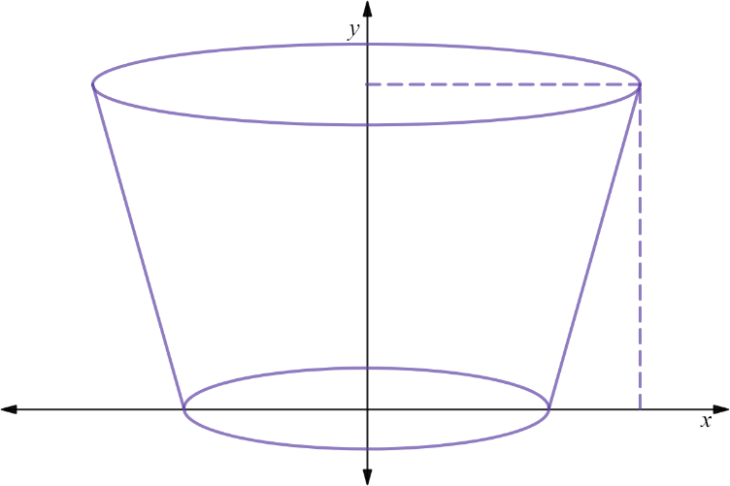
$$(R, H)$$

$$(r, 0)$$

gradient of edge of bucket $=$ $\frac{H-0}{R-r}$ $=$ $\frac{H}{R-r}$

equation of line $y-0=$ $\frac{H}{\left(R-r\right)}$ $\left(x-r\right) ⇒ x=$ $\frac{\left(R-r\right)}{H}$ $y+r$

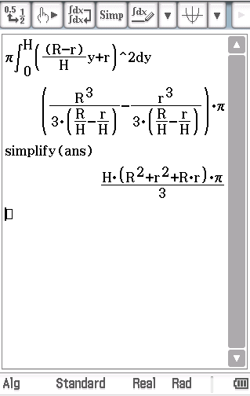
$V_{y}=π\int_{m}^{n}{x^{2}dy}$

$= π\int_{0}^{H}{{\left(\frac{\left(R-r\right)}{H} y+r\right)}^{2}dy}$

$=$ $\frac{πH}{3}$ $(R^{2}+r^{2}+Rr)$ ${cm}^{3}$

7. [5 marks]

Below is shown the uniform cross-section of a drainage canal (shaded), the bed of which is described by curves; $4y+$ $e^{5xln2}$ $=2$ and $4x+y = 2.5x^{2}$, where $x$ and $y$ are measured in metres and the $x$ axis represents the water level. If the water is flowing at the rate of $3.5 m/s$ then how many kilolitres (to the nearest kL) of water will pass by in two minutes.
Note: 1 m³ = 1kL
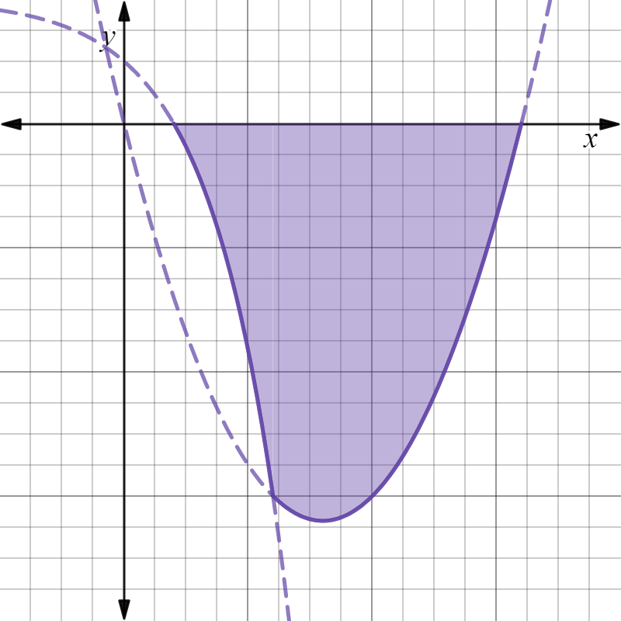

$$\left(0.2,0\right)$$
$$\left(1.6,0\right)$$

$$\left(0.6,-1.5\right)$$

$4y+$ $e^{5xln2}$ $=2 ⇒ y=$ $\frac{1}{2}-\frac{e^{5xln2}}{4}$ and $4x+y = 2.5x^{2} ⇒ y=2.5x^{2}-4x$

$∴$ Area $=-\int_{0.2}^{0.6}{(\frac{1}{2}}-\frac{e^{5xln2}}{4})$ $dx +(-$ $\int_{0.6}^{1.6}{(2.5x^{2}-4x})dx)$

$≈0.2328+$ $1.1667$

$≈1.3995$

$∴$ Volume of water $=1.3995 m^{2}×3.5 ms^{-1}×120s$

$≈587.78 m^{3}$

$=588 kL$to the nearest $kL$

8. [3, 2 = 5 marks]

The ellipse shown has equation $\frac{x^{2}}{a^{2}}+\frac{y^{2}}{b^{2}}$ $=1$ with $a>b>0$ .

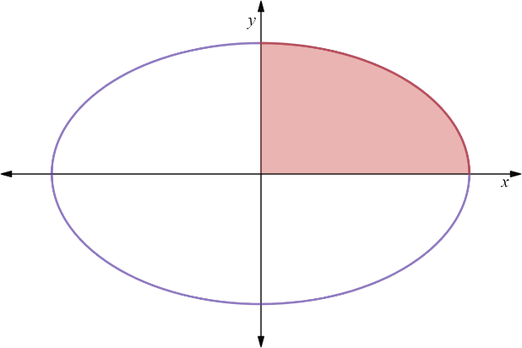

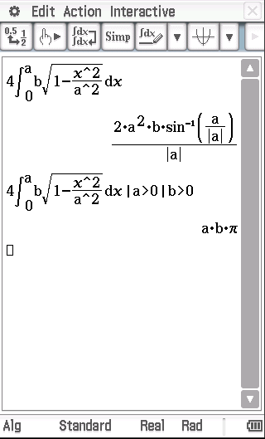
Use a suitable integral to determine, in terms of $a and b$,

- the area of the ellipse.

$\frac{x^{2}}{a^{2}}+\frac{y^{2}}{b^{2}}$ $=1 ⇒ y=b$ $\sqrt{1-\frac{x^{2}}{a^{2}}}$

$∴$Area $=4$ $\int_{0}^{a}{b\sqrt{1-\frac{x^{2}}{a^{2}}}}$ $dx$
$=πab$

- the volume of the ellipsoid formed by rotation of the ellipse about the $x$ axis.

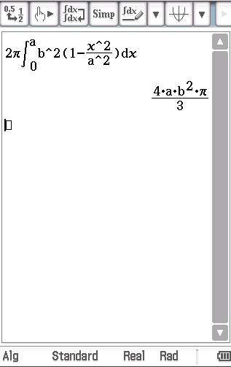
${Volume}_{x}=π\int_{-a}^{a}{y^{2}}dx$

$=2π\int_{0}^{a}{y^{2}}dx$

$=2π$ $\int_{0}^{a}{b^{2}\left(1-\frac{x^{2}}{a^{2}}\right)}$ $dx$

$=$ $\frac{4πab^{2}}{3}$

End of Section Two

